SRINIVAS UNIVERSITY
INSTITUTE OF EDUCATION

RANK LIST OF B.Ed. 2021-22 BATCH

SHAMITHA S ALVA  Gold Medal and 1st Rank  B.Ed. | 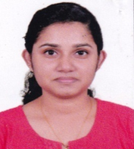  RAINA HENCIL DMELLO  2nd Rank  B.Ed. | 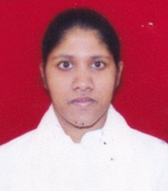  BLESSY MARTIN  3rd Rank  B.Ed. | 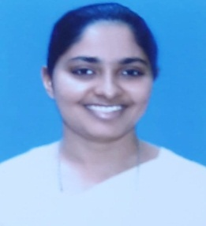  LEONA NISHA GALBAO  4th Rank  B.Ed.
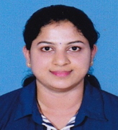  SWATHI KUMARI  5th Rank  B.Ed. | POOJA P  6th Rank  B.Ed. | 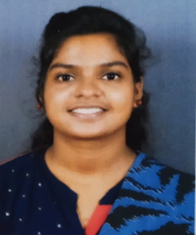  RESHMA ROCCO  7th Rank  B.Ed. | 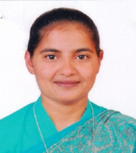  MARGRATE GRACY J  8th Rank  B.Ed.

***************************

